**Python Set Up:**

1. Download python 3.7.2 setup from

<https://www.python.org/downloads/>

1. Scroll to the bottom and select either Windows x86-64 executable installer for 64-bit or Windows x86 executable installer for 32-bit
2. Run the Installer
3. You can confirm the installation by opening up Command Prompt and typing the following command:

**python -V**

**Add python path in windows:**

To add the path to the python.exe file to the Path variable, start the Run box and enter sysdm.cpl

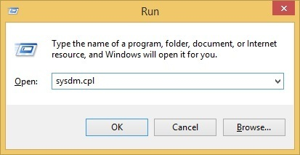

This should open up the System Properties window. Go to the Advanced tab and click the Environment Variablesbutton:

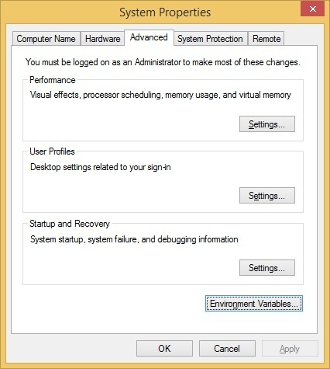

In the System variable window, find the Path variable and click

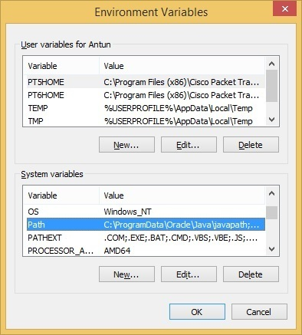

Position your cursor at the end of the Variable value line and add the path to the python.exe file, preceeded with the semicolon character (;). In our example, we have added the following value: ;C:\Python34

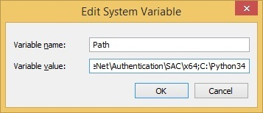

IDE’S:

## Sublime Text 3

* + <https://www.sublimetext.com/3>

## Atom

* + <https://atom.io/>

## PyCharm

* + <https://www.jetbrains.com/pycharm/download>

## Visual Studio Code

* + <https://code.visualstudio.com/download>
* Anaconda
  + <https://www.anaconda.com/distribution/>
  + After Installation run the below command on terminal

Run “jupyter notebook

**Reference:**

<https://realpython.com/installing-python/>

[**https://stackoverflow.com/questions/3701646/how-to-add-to-the-pythonpath-in-windows-so-it-finds-my-modules-packages**](https://stackoverflow.com/questions/3701646/how-to-add-to-the-pythonpath-in-windows-so-it-finds-my-modules-packages)